# Exercises: Create а Crowdsale without Coding

**ICO Wizard** is a client-side tool to create token and crowdsale contracts in five steps. It helps you to publish contracts on the Ethereum network, verify them in Etherscan, create a crowdsale page with stats. For participants, the wizard creates a page to invest into the campaign.

Smart contracts based on TokenMarket contracts.

## Exercise

* 1. Go to <https://wizard.oracles.org>

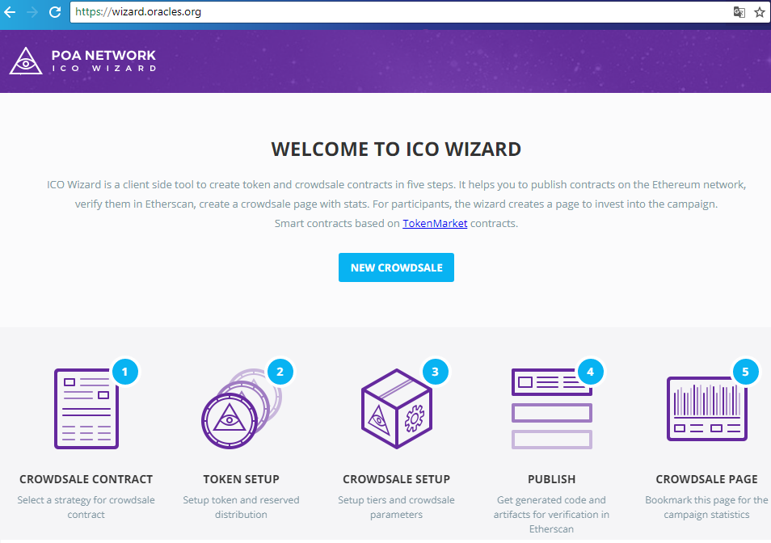

* 1. Unlock your account from Metamask wallet and create new crowdsale.

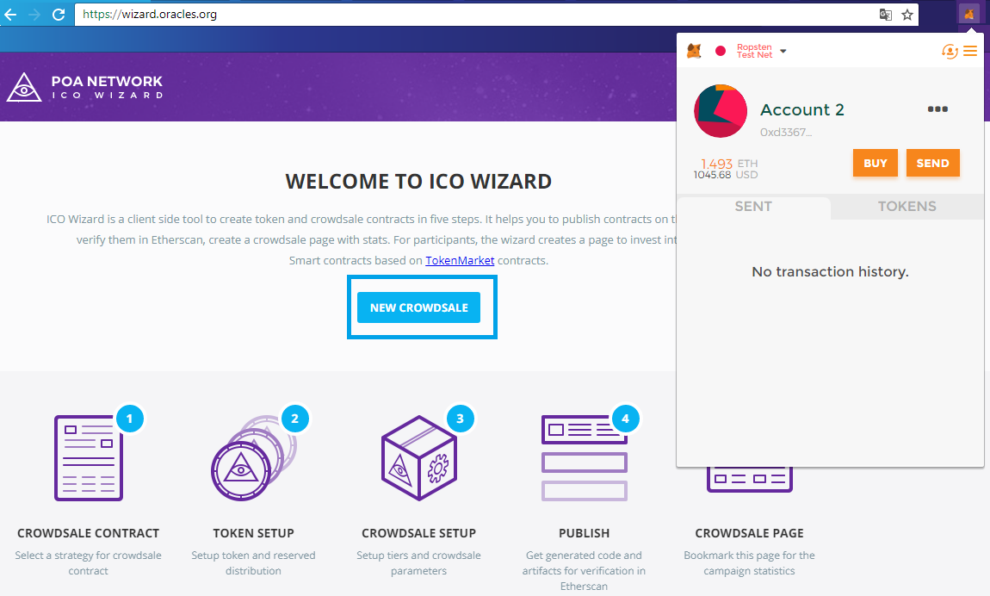

* 1. Select a strategy for your crowdsale and continue.

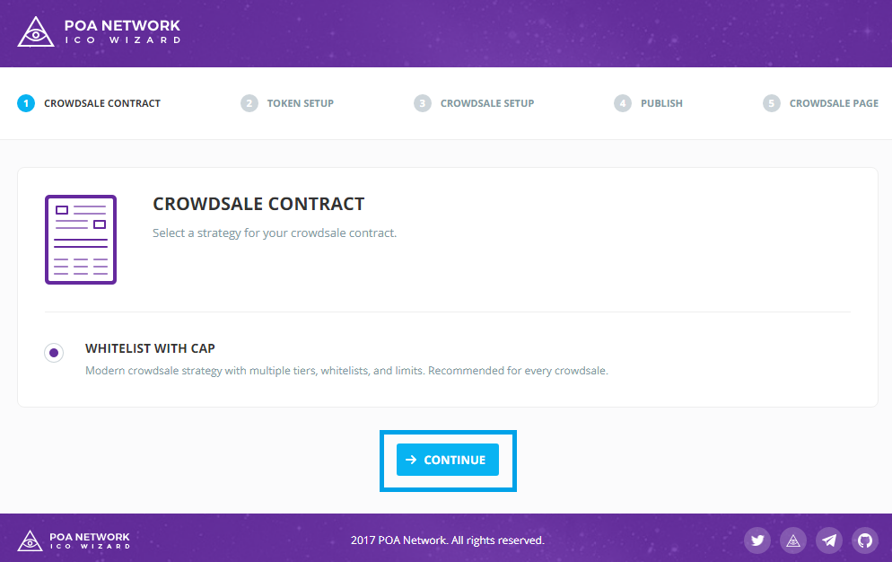

* 1. Give your token a name, symbol and decimals (how divisible can be your token – up to 18).

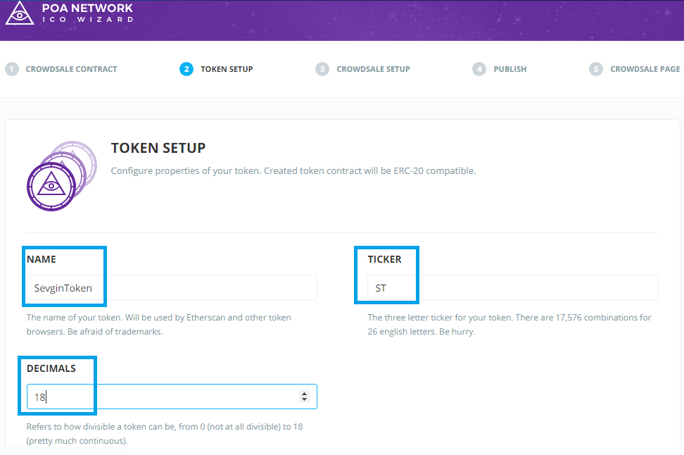

* 1. Choose where to be sent the reserved tokens. It can be percentage or tokens. Write address and value.

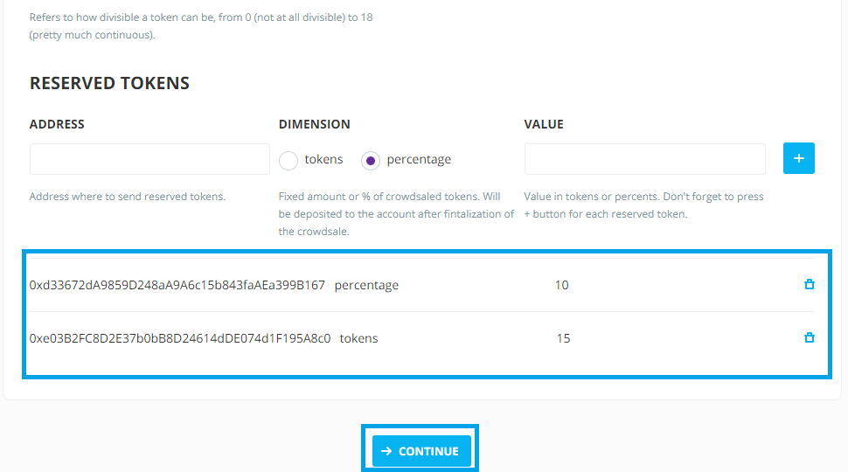

* 1. Choose where to go the money after the investors transactions. You can also choose the gas price and the minimum cap.

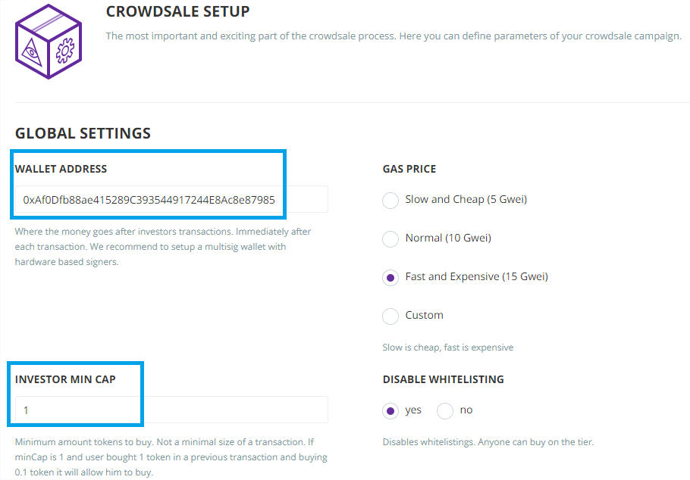

* 1. We will have two tires. The first is the PreICO and we will give 100 ST for ETH and it will continue 4 days. The total supply will be 100000.

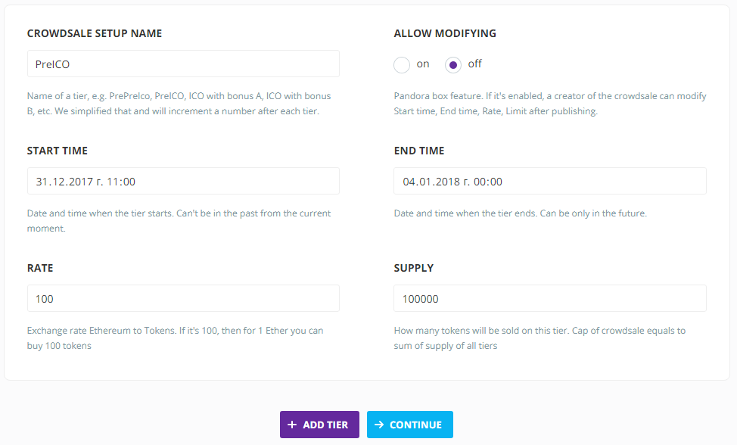

* 1. We will also have the MainICO it will continue 3 days and it will give 50 ST for ETH. The total supply will be 200000.

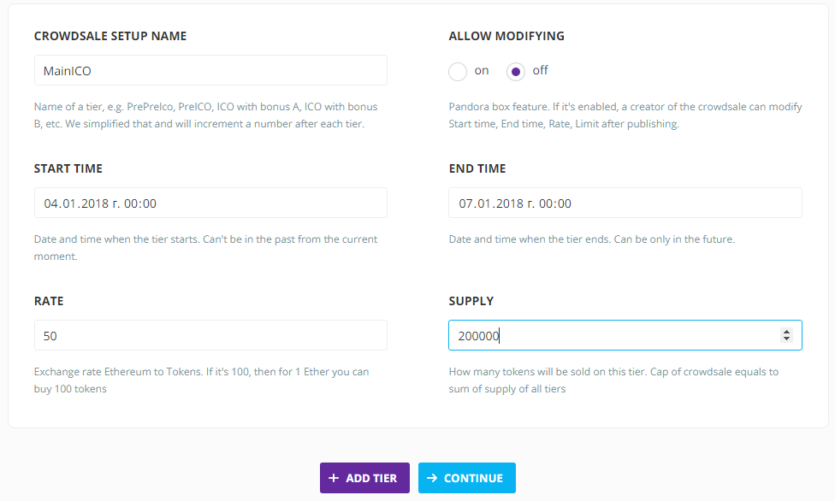

* 1. Click “Continue” and submit the transaction.

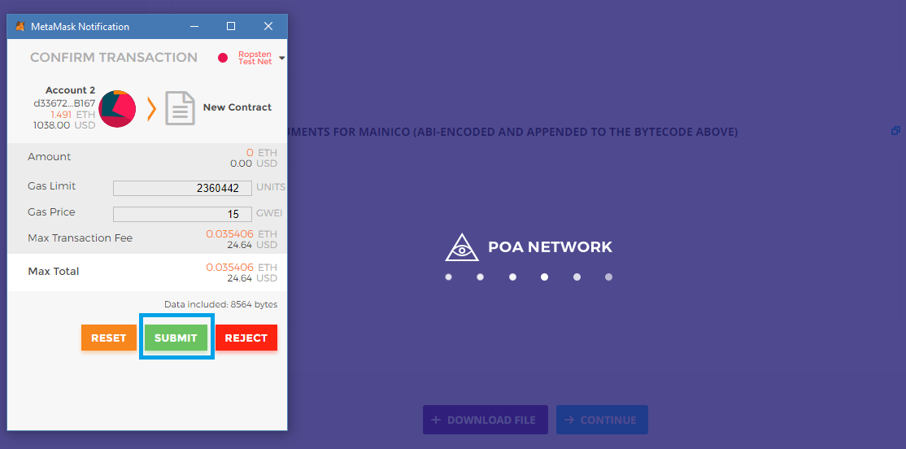

* 1. Wait until it is published.

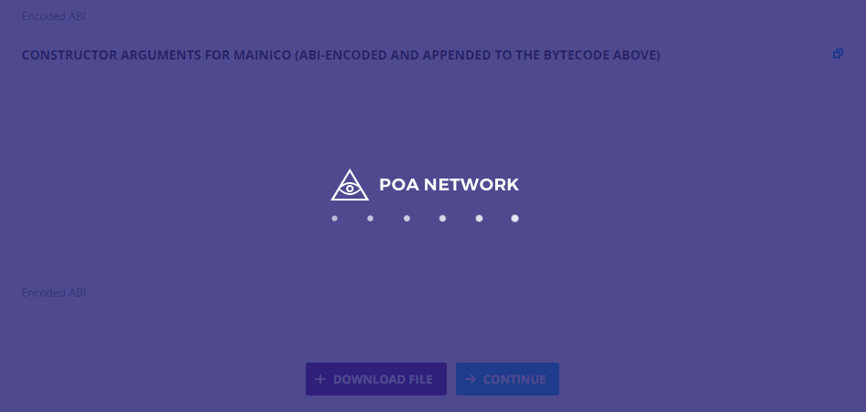

* 1. After publishing you can see how the contract looks. The token basic information.

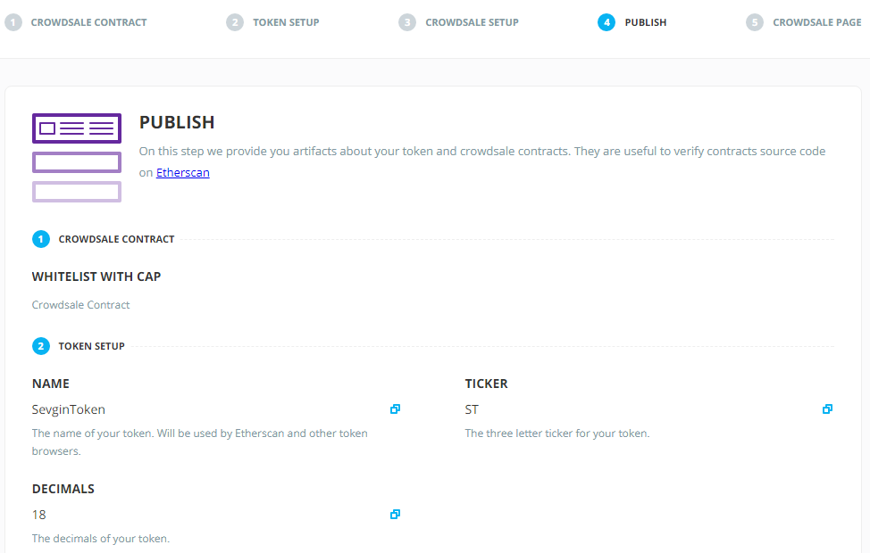

* 1. The ICO information.

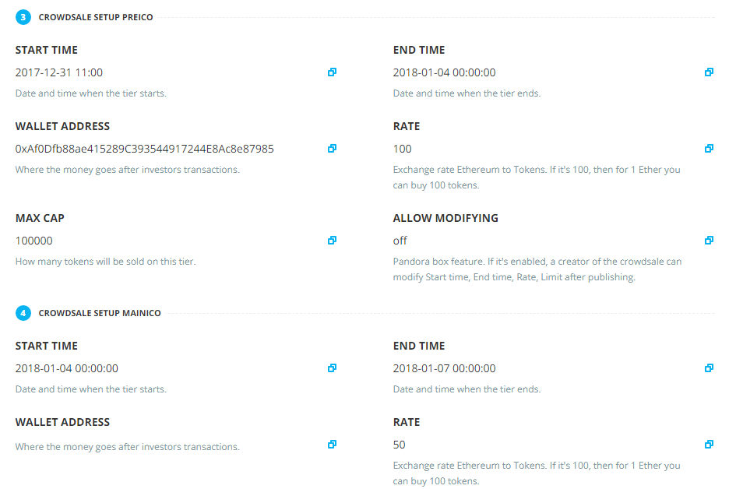

* 1. The Token Contract source code and ABI.

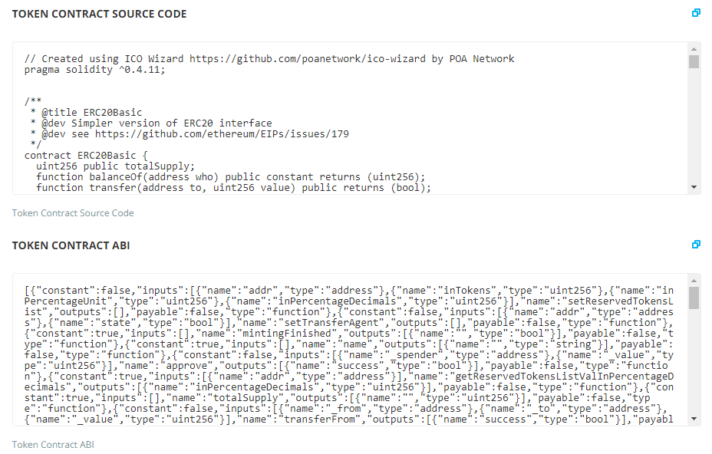

* 1. The Pricing Strategy Contract source code.

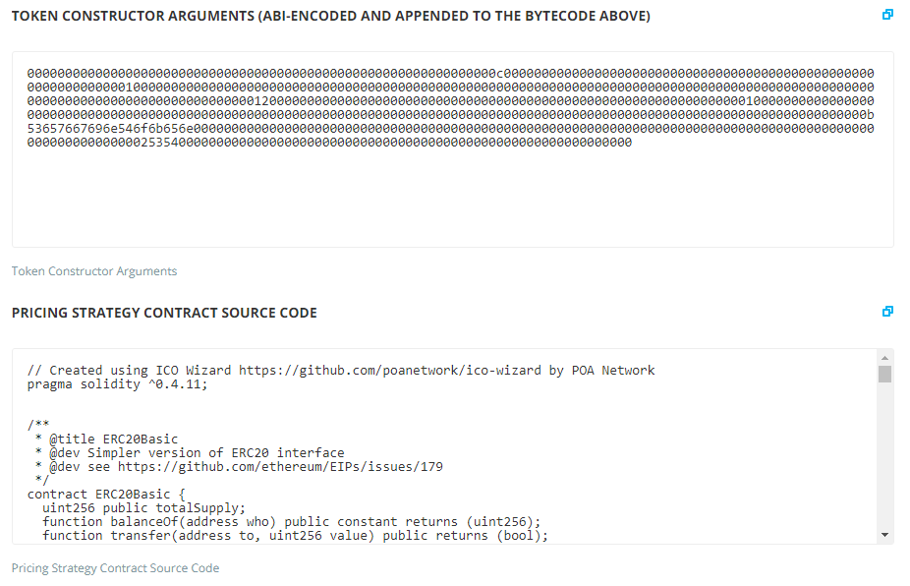

* 1. The Pricing Strategy Contact ABI.

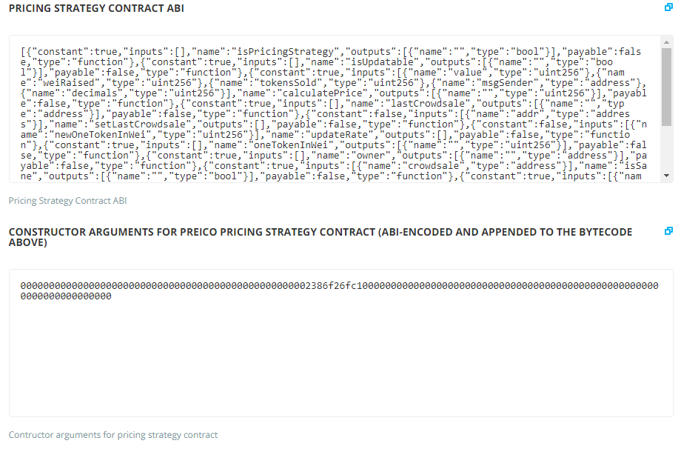

* 1. The Finalize Agent contact source code.

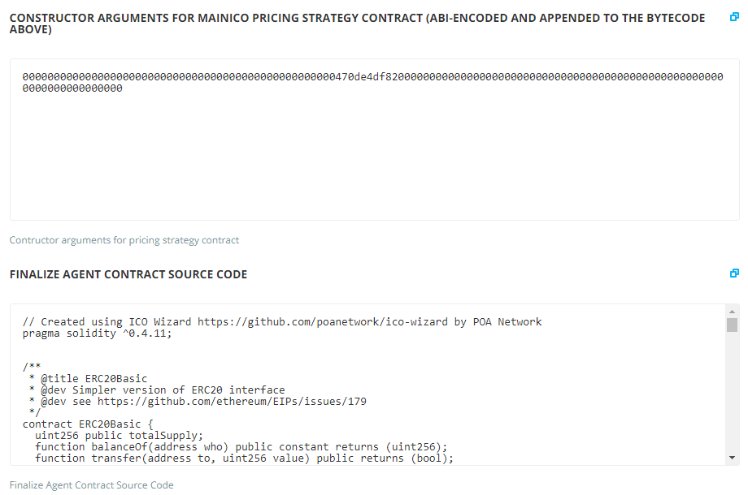

* 1. The Finalize Agent contact ABI.

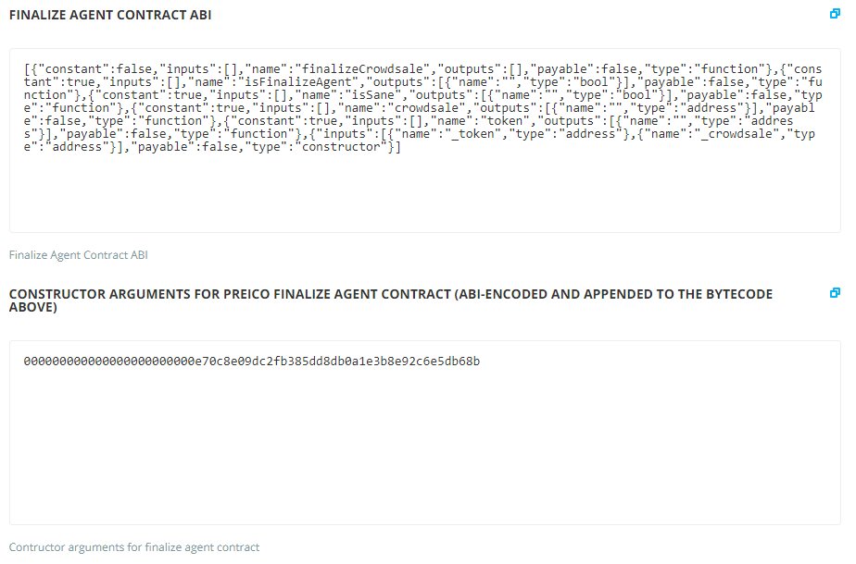

* 1. Crowdsale Contract source code.

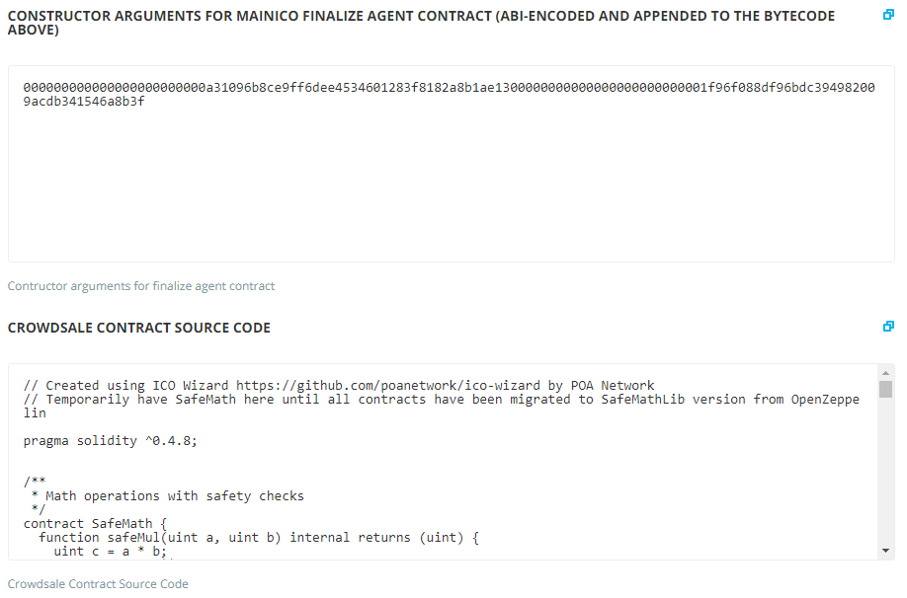

* 1. Crowdsale Contract ABI.

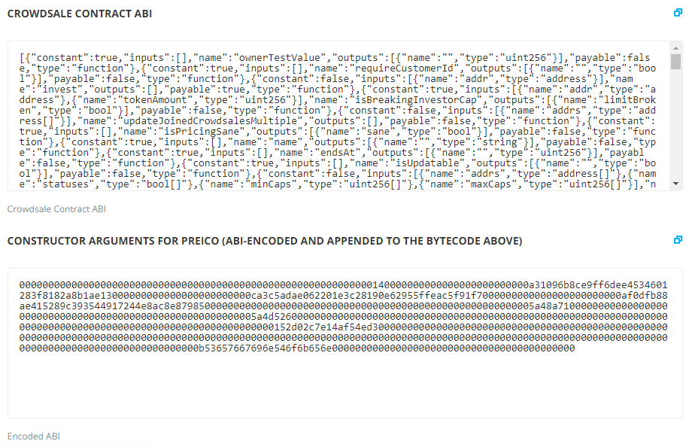

* 1. You can download the whole information and continue.

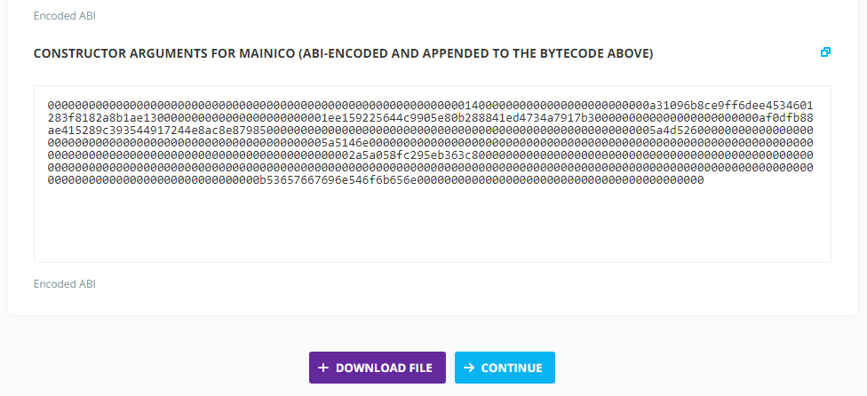

* 1. The whole downloaded information should look like the window below.

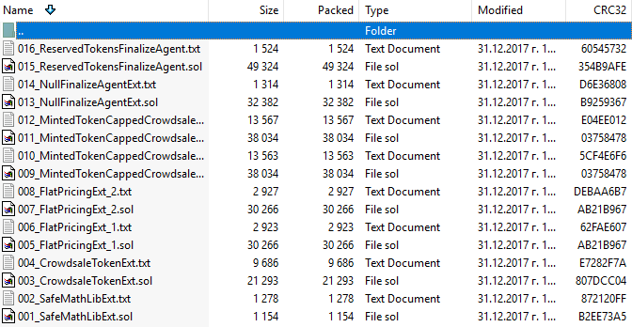

* 1. This is the Crowdsale page. Here is the information for how much ETH are contributed. The goal, the price, the contributors and so on. You can invest from another address by clicking “Invest” button.

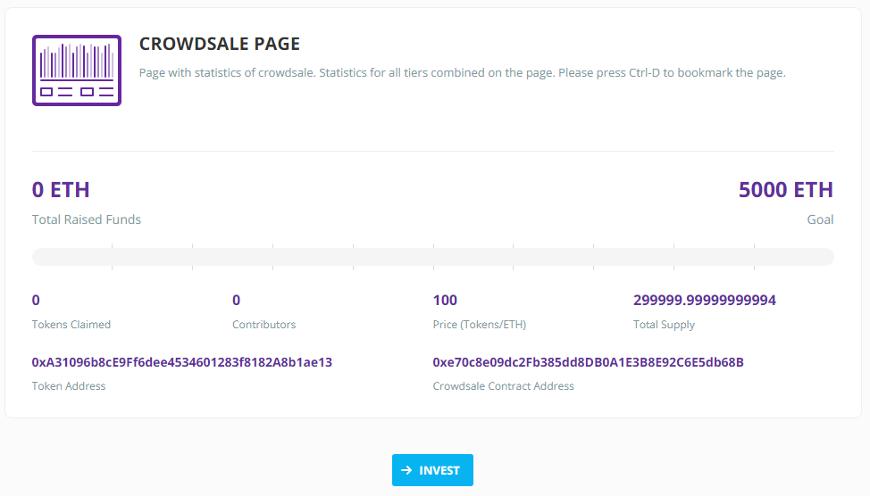

* 1. Unlock your Metamask account, choose the amount of tokens you want to buy and “Contribute”.

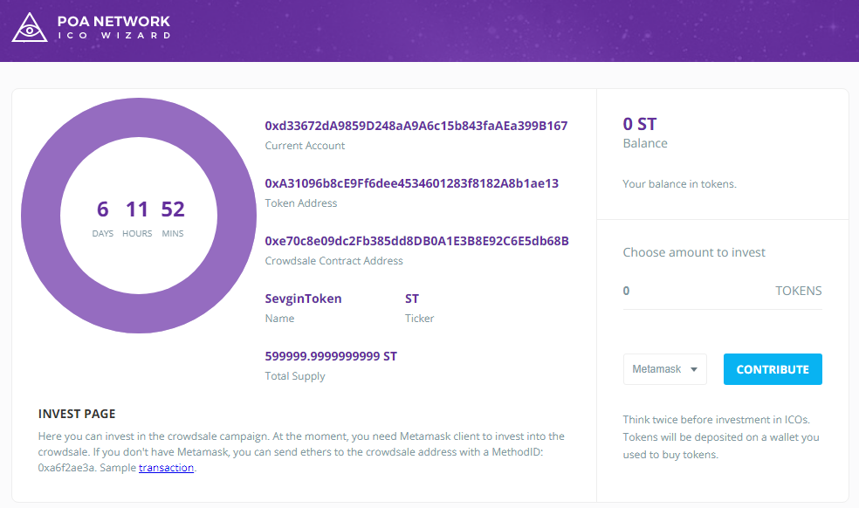

* 1. For example 90 ST will cost 0.9 ETH.

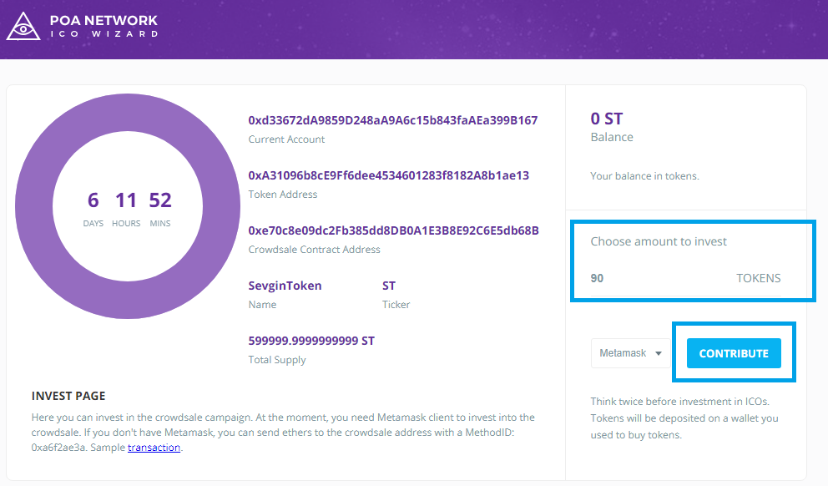

* 1. Submit the transaction from the account you want to invest.

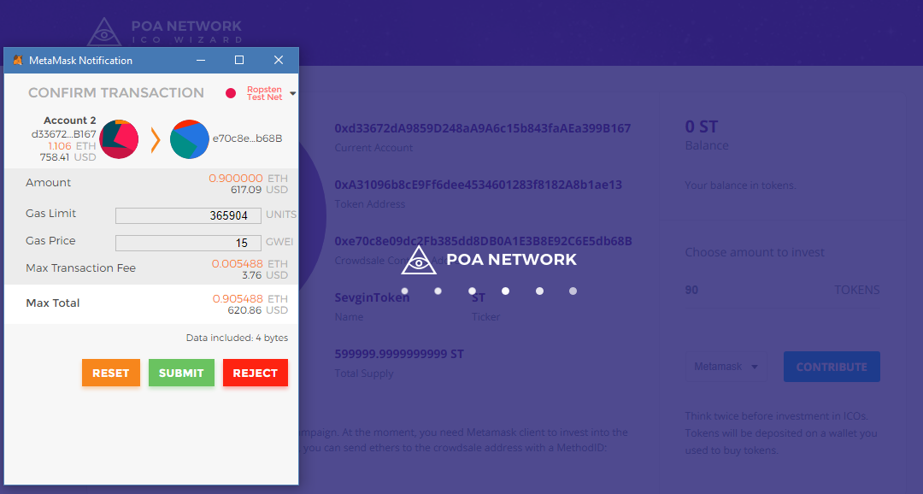

* 1. After investing you will see the ST tokens as your balance.

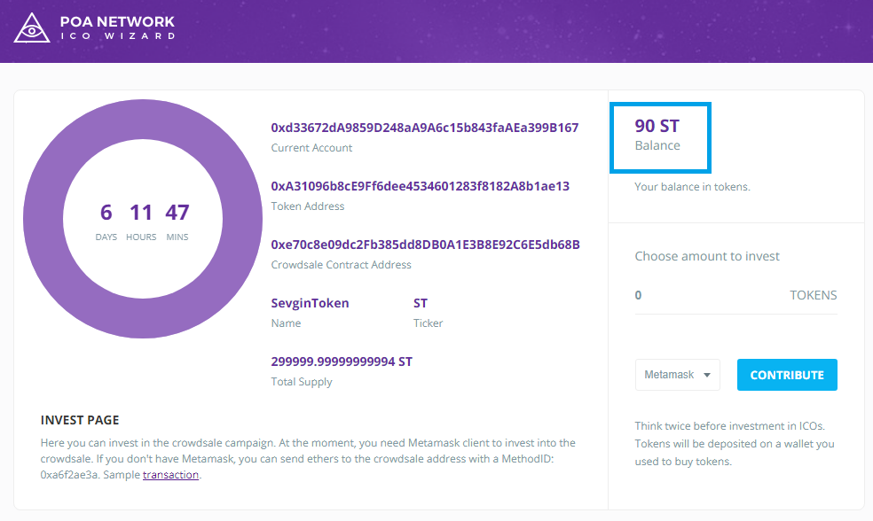

* 1. You can check you balance by going to <https://ropsten.etherscan.io> and type your address. Then look at the “View Tokens” for ST tokens. You can see the transaction below.

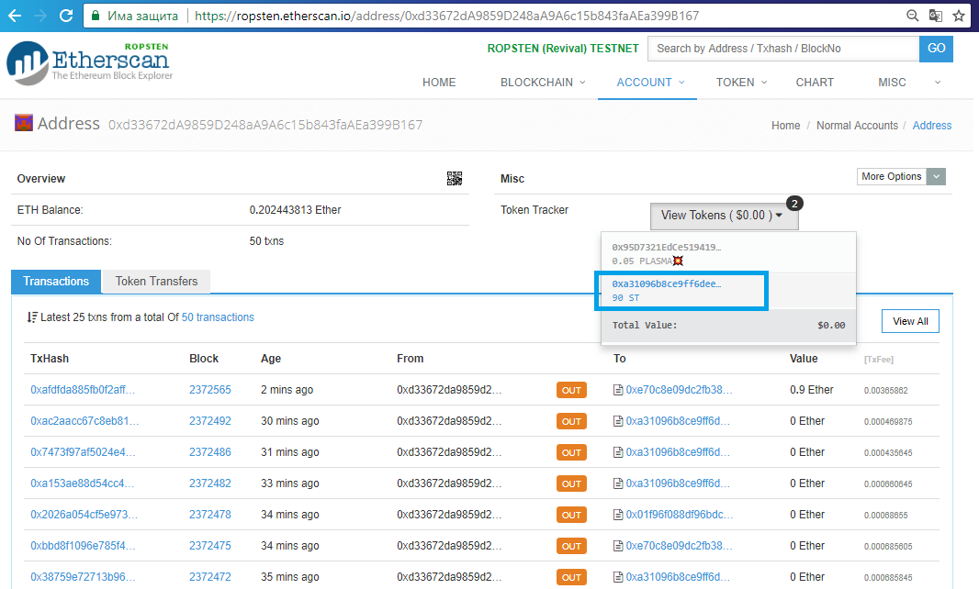

* 1. You can see where the investments go. Here you will see the transactions made. Go to “Internal Transactions” and you will find where the tokens go.

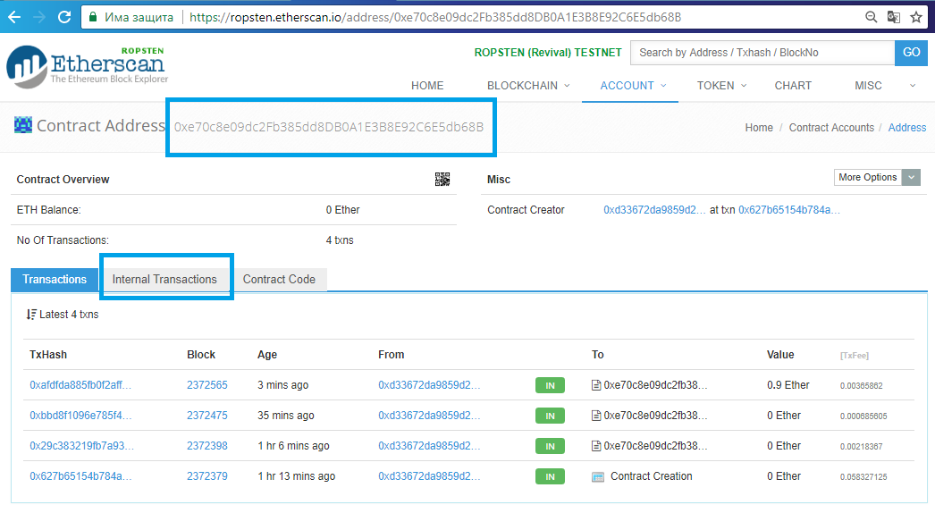

* 1. This is the address where the investments come.

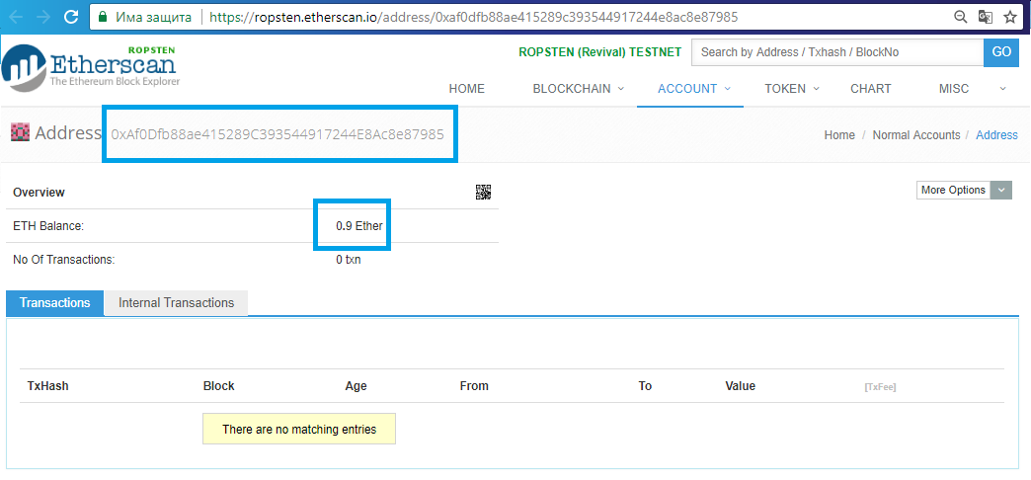

* 1. Here you can see the total raised funds. As you see after you have invested 0.9 ETH the information have changed. Now there are 1 contributors and 90 tokens claimed.

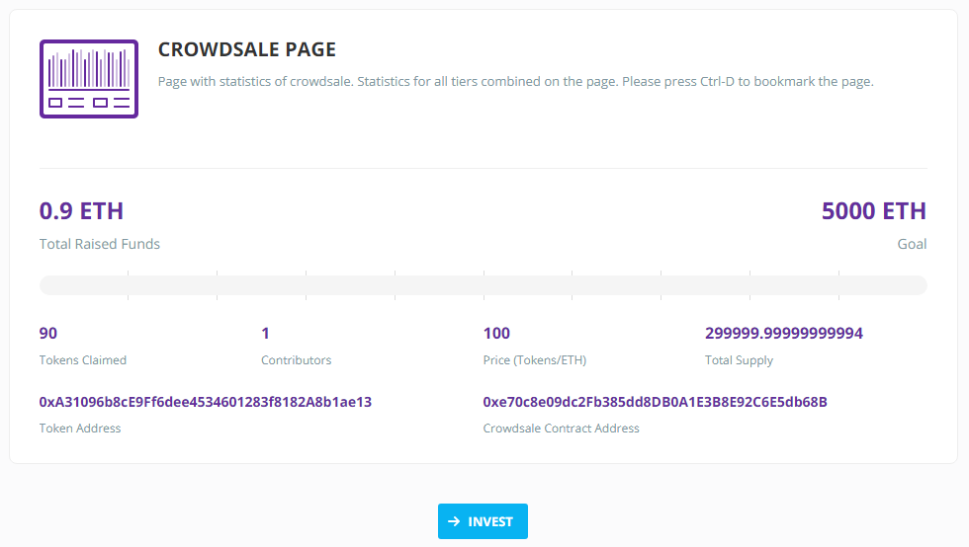

Congrats! Now you can create crowdsale without coding and also can invest in one.

# What to Submit?

Submit as exercise outcome the **address of the crowdsale** you’ve created in the Ropsten network e.g.:

* <https://ropsten.etherscan.io/address/0xb97e993872a903850c07fbd999a6e750963ef195>

You should some **transaction** history. Examples:

